**A Hybrid Approach For Recommender System**

**ABSTRACT**

Recommender systems represent user preferences for the purpose of suggesting items/deals to purchase or examine. Our main goal is to recommend a product or deal to a user based on their behavior. In our system, we will collect some inputs from the users through an app. Using these inputs, a variety of techniques have applied for performing recommendation, including item-item collaborative filtering, user-user collaborative filtering, and matrix factorization. To improve performance, these methods have been combined to form a hybrid recommender system. Individuals will discover the system progressively valuable when it satisfies their decision or intrigue. As they will discover the system progressively helpful, they will begin utilizing the system in the entirety of their part of their life.

**Method with System Diagram/Design Complexity**

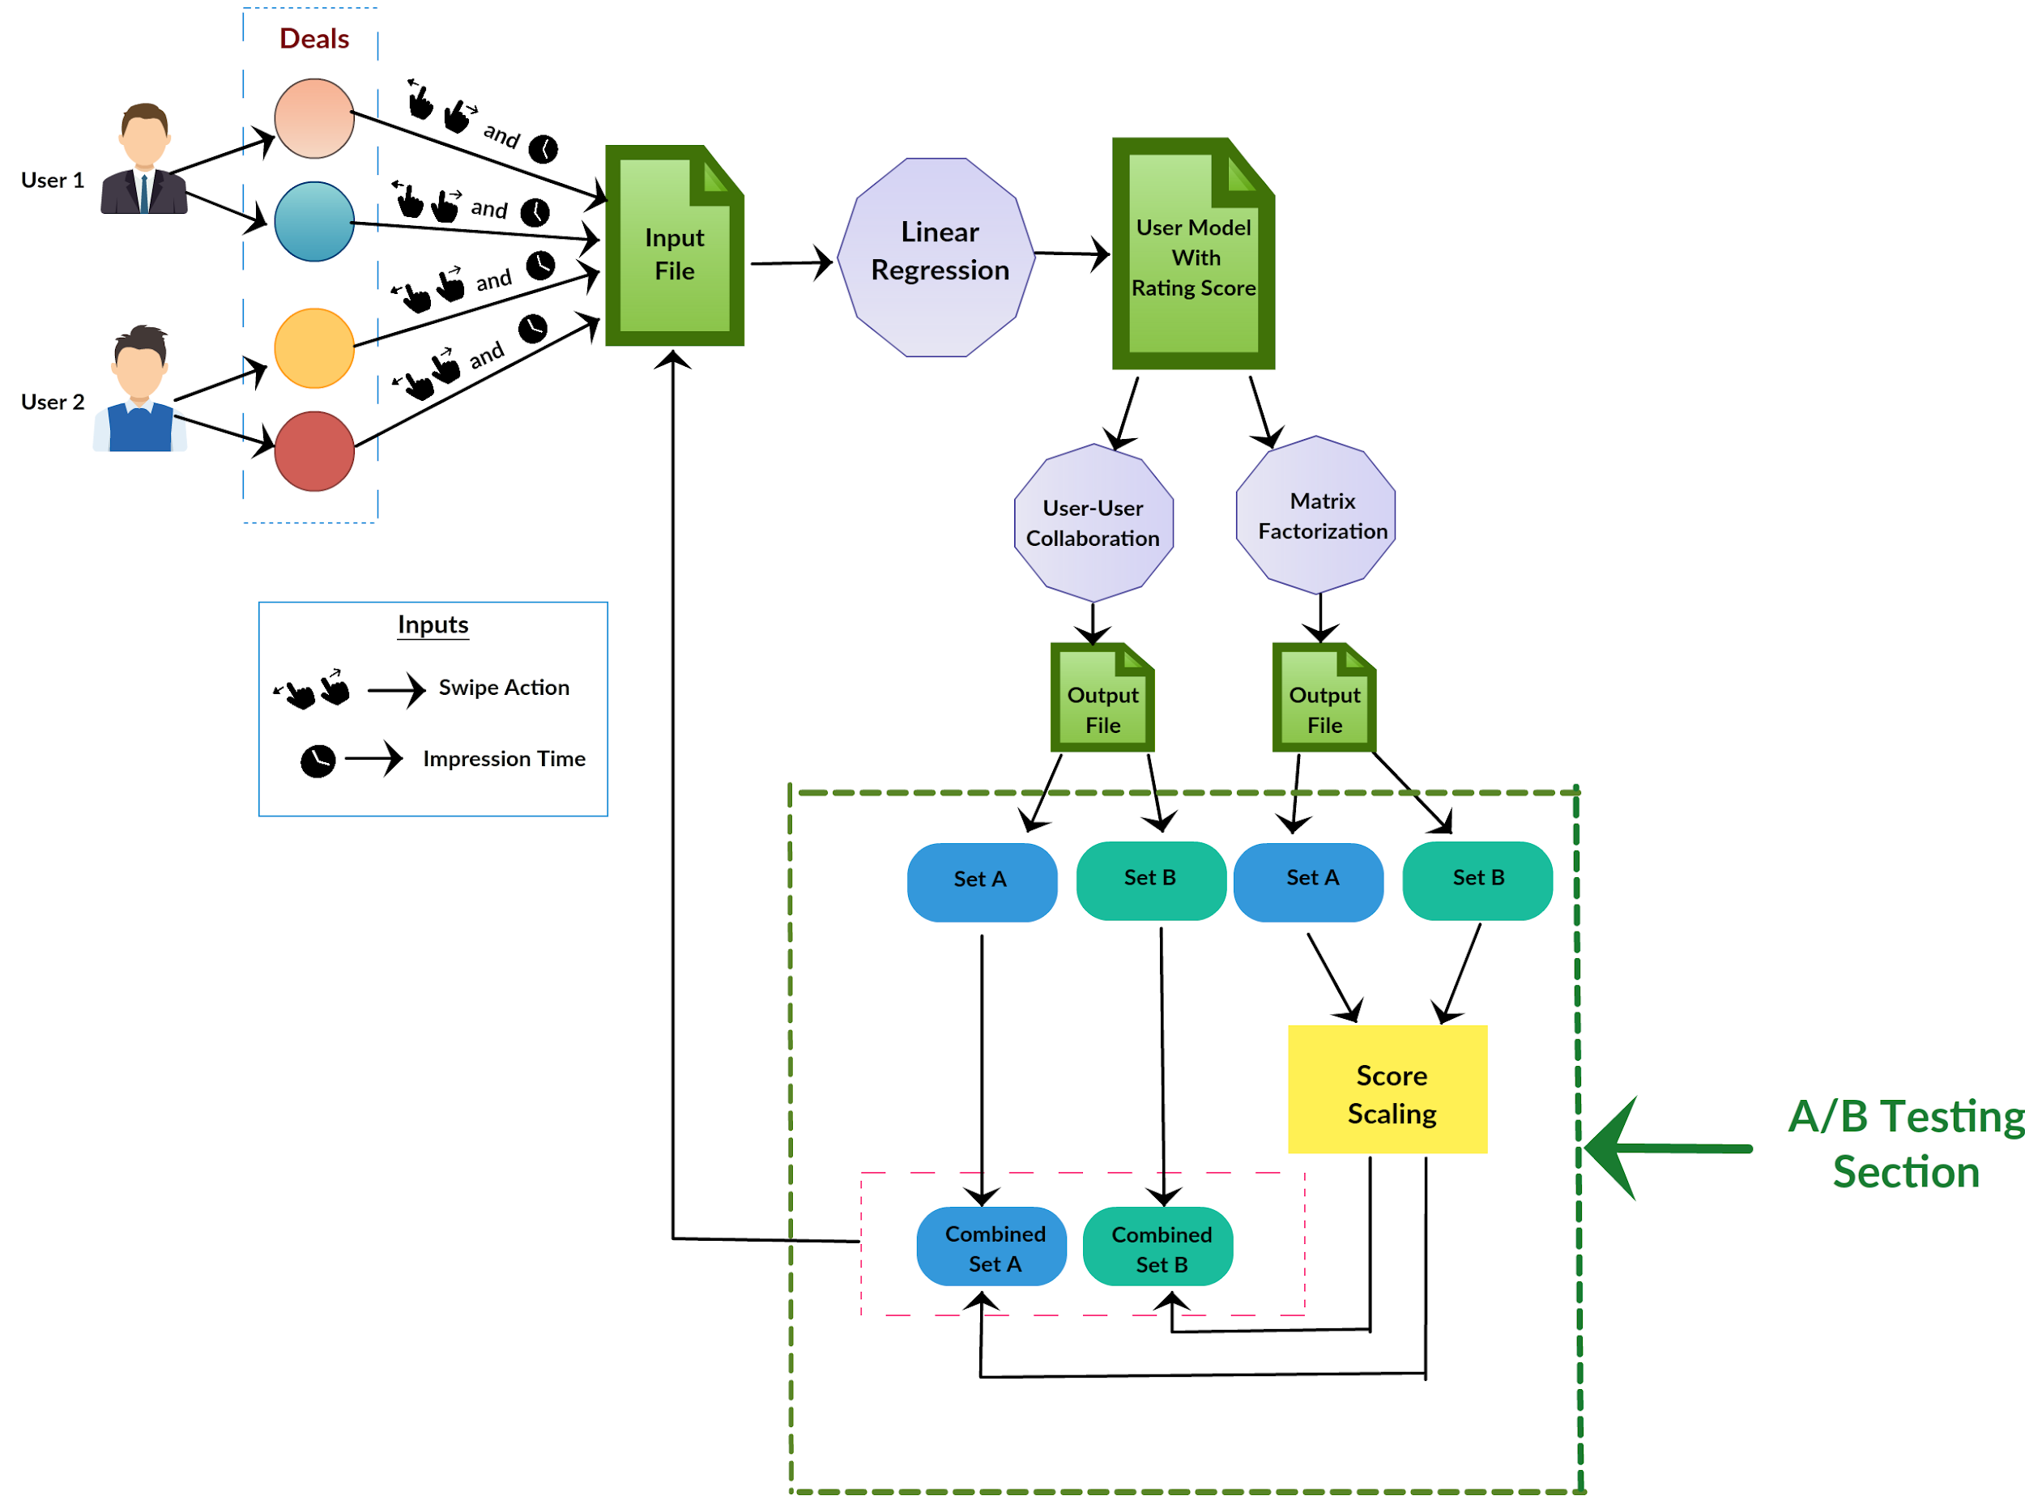

Figure 1: System diagram of recommender system.

The deal which will be viewed by the user, we will take them as the input from the user. For a new user, we will score the deals with a random value between 0-100. The score will lower for those deal which they don’t like and a higher score for which they like them. This score also depends on some other parameters like the time a user is viewing a deal. Based on this input we will run linear regression for each user to get the user model. This will be used to get the score from the deals viewed by the user. After that, we will use matrix factorization and user-user collaboration to get recommended A and B set for the user from both of the model. We have to do some score scaling for matrix factorization score for getting the same range score as user-user collaboration. After that, we will merge those A and B set from both models to convert them to particular A and B set. From this recommended item, which will be viewed by the user will send as input to our recommendation system.

**Novelty of Project and Significance**

In our recommendation system, we have used a hybrid model(user-user collaborative filtering and matrix factorization) approach. This system is not just able to reduce the common recommender issues like new items to be recommended, avoiding the previous recommendations and no new recommendations to be added because temporal dynamics can’t be added but it is also able to scale as needed to accommodate an increase in customer base. In our test environment, the performance parameters are faster than a relative collaborative filtering model running on the same system. The best part is that you don’t have to build two models. You can use the same model to derive both collaborative filtering and matrix factorization recommendations.

**Impact on society**

The use of a recommendation system on an app or a system gives a user a friendly environment to use the system. People will find the application or software more useful when it fulfills their choice or interest. As they will find the system more useful, they will start using the system in all their aspect of their life. It will save time in many ways and can make their life easier.

**Business Model**

By using the recommendation system, a company can understand user behavior. What kinds of service they are expecting. By analyzing these, a company can take the important decision which will have a positive impact on their revenue. As we know, the final goal of a business is to increase the revenue; the recommender system can have a great positive effect to earn this goal.￼￼